MAIN SUB PAGE
STEEL SIDING & SOFFIT
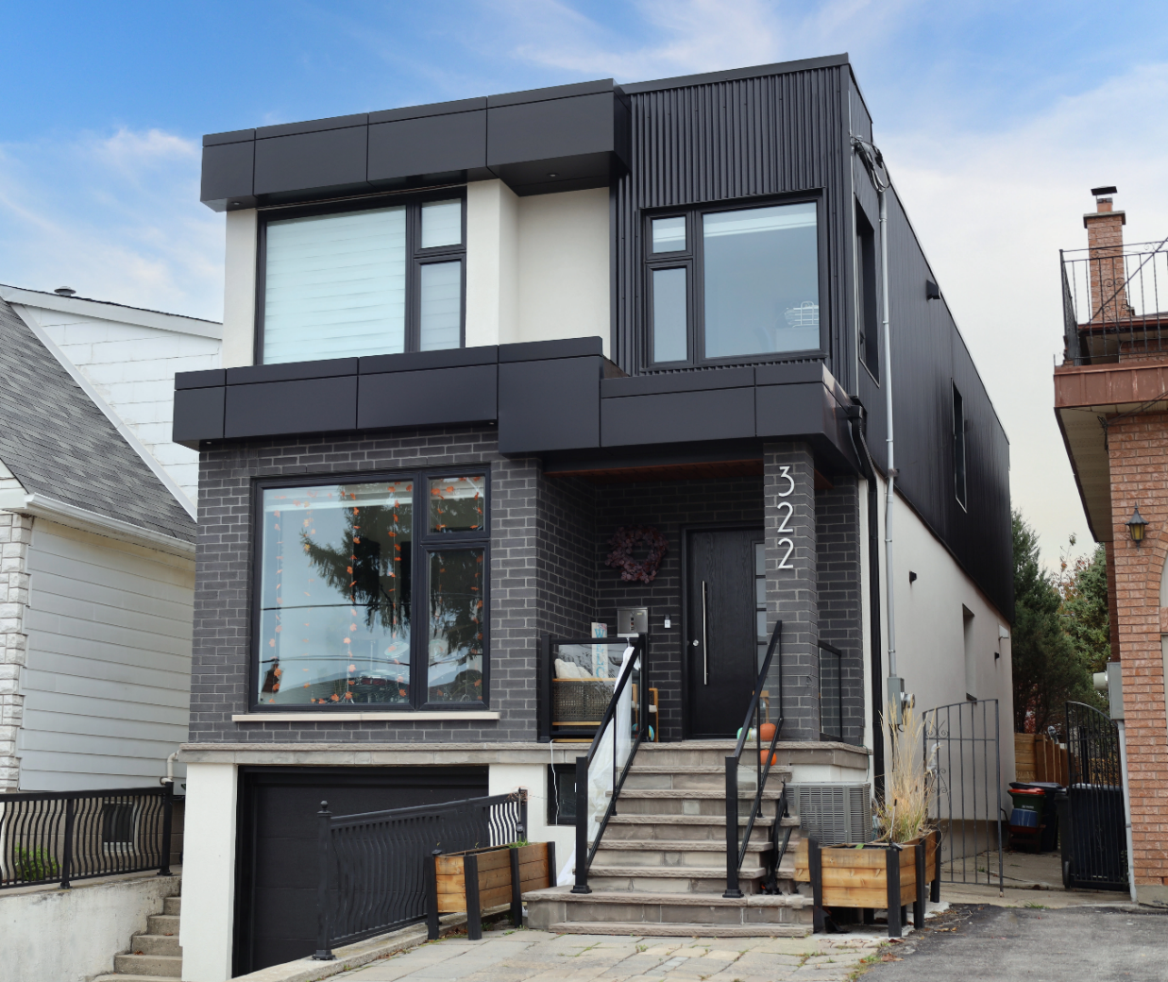
Industrial / Residential / Commercial / Agricultural
Durable, stylish, and cost-effective, metal siding panels offer a modern and long-lasting solution for residential and commercial projects. Made from high-quality steel, these panels provide excellent protection against harsh weather, fire, and pests while enhancing energy efficiency. Their low maintenance requirements and longevity make them a budget-friendly choice over time. With a variety of profiles, finishes, and colors available, metal siding delivers both aesthetic appeal and structural resilience, making it a smart investment for any building.
Curious about the advantages of steel siding? Visit our blog to explore the compelling reasons why this choice stands out for homeowners seeking durability and style.
Speak with an Expert Get personalized advice and expert guidance to achieve your project goals with confidence.
CUSTOM TRIM & FLASHINGS MENU ICON (PREVIEW)

Trims & Flashings Steel Siding & Soffit
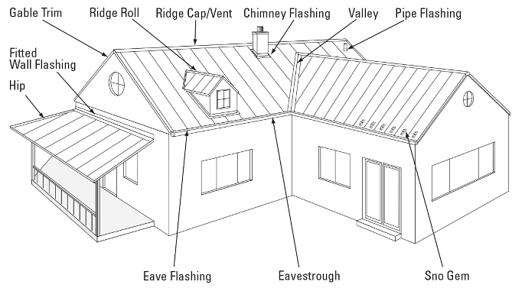
Need flashings and trims? We’ve got you covered down to every last detail. At Cladcan, we specialize in fabricating high-quality, custom flashings and trims designed to meet the specific needs of your commercial, industrial, or institutional building project..... (Learn More / Expand)

TRIMS & FLASHINGS Steel Siding & Soffit (EXPANDED)
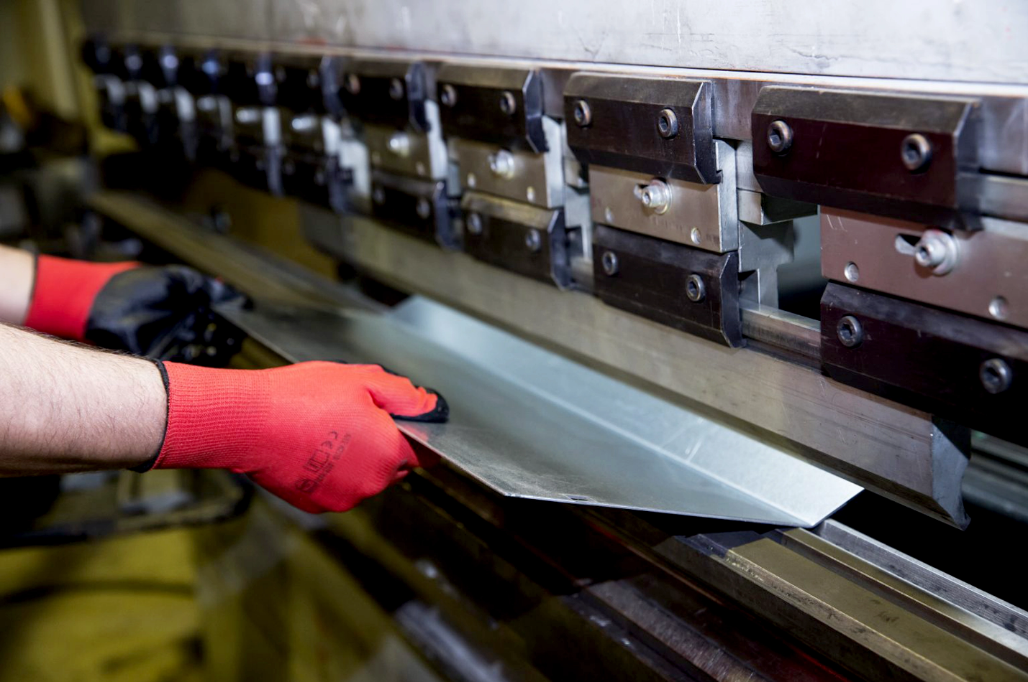
Expanded …Need flashings and trims? We’ve got you covered down to every last detail. At Cladcan, we specialize in fabricating high-quality, custom flashings and trims designed to meet the specific needs of your commercial, industrial, or institutional building project. Whether you’re working with complex architectural lines or standard building envelopes, we ensure the perfect fit and finish.

Our offering includes everything from outside corners, jambs, parapet caps, coping flashings, sills, starter trims, and more — all available in a wide variety of gauges, colors, finishes, and materials including pre-painted steel, aluminum, and specialty metals.

Backed by expert craftsmanship and quick turnaround times, our flashings don’t just complete the job — they elevate it. Whether you bring us detailed drawings or just an idea, we’ll deliver trims that meet your specs and perform for the long haul.

Standard Flashings
If you need a specific flashing shape, we can fabricate it. Cladcan provides a full range of flashings and trims to complete your commercial or industrial building project. From outside corners to jambs and coping flashings, we’ve got you covered.

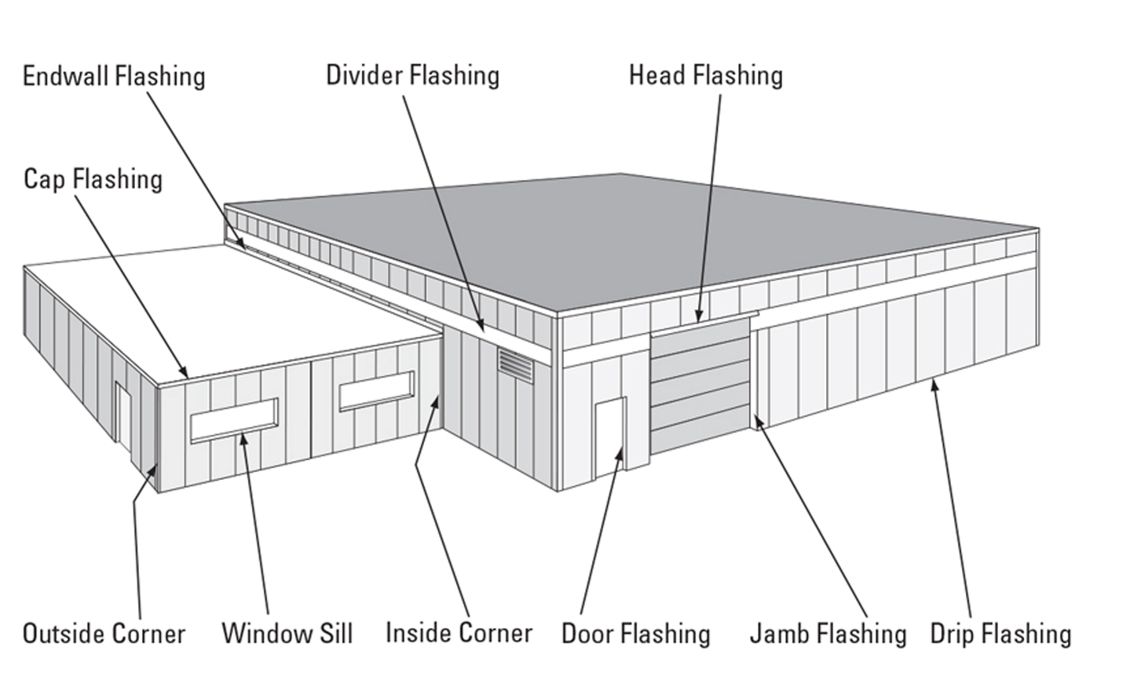

Outside and Inside Corners
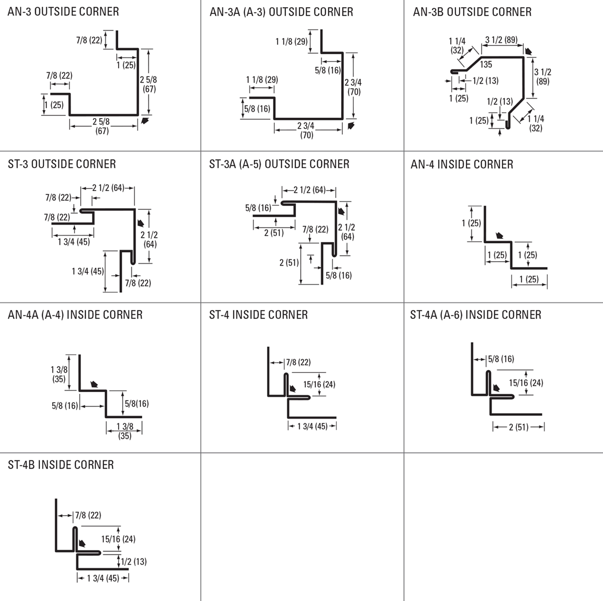

Drip and base Trims, Gable Dividers
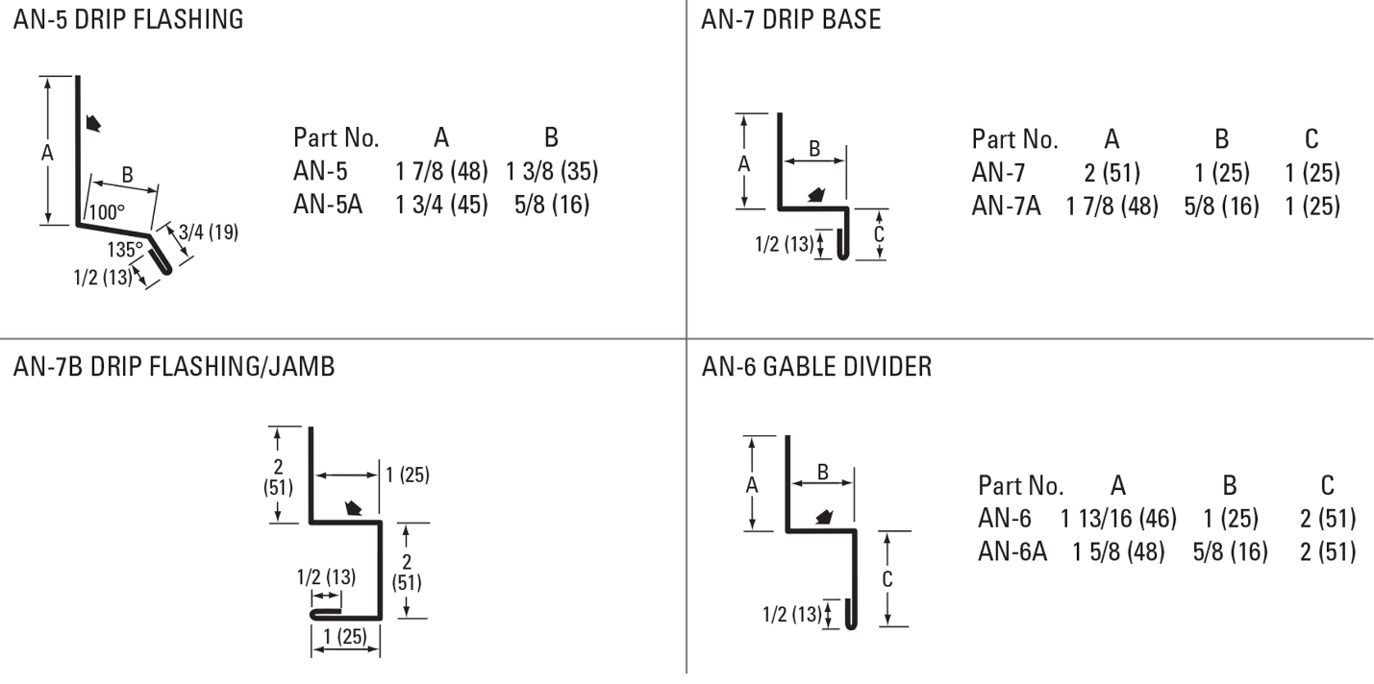
Soffit & Gable Trims, Eaves Starters, Jamb Fkashings
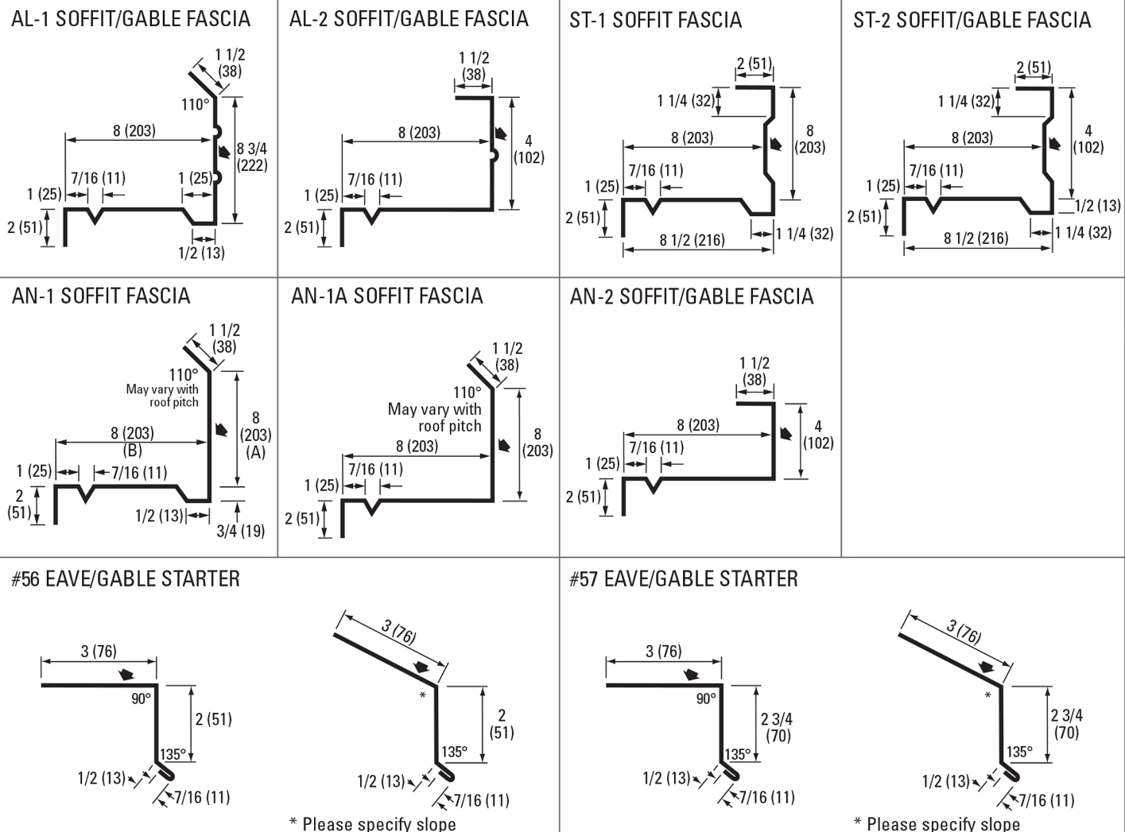
Hip Flashings, Endwalls, J-Trims, Ceiling & Sliding Door Trims
